https://www.dw.com/en/elnaz-rekabi-iranian-climber-arrives-back-in-tehran/a-63484340

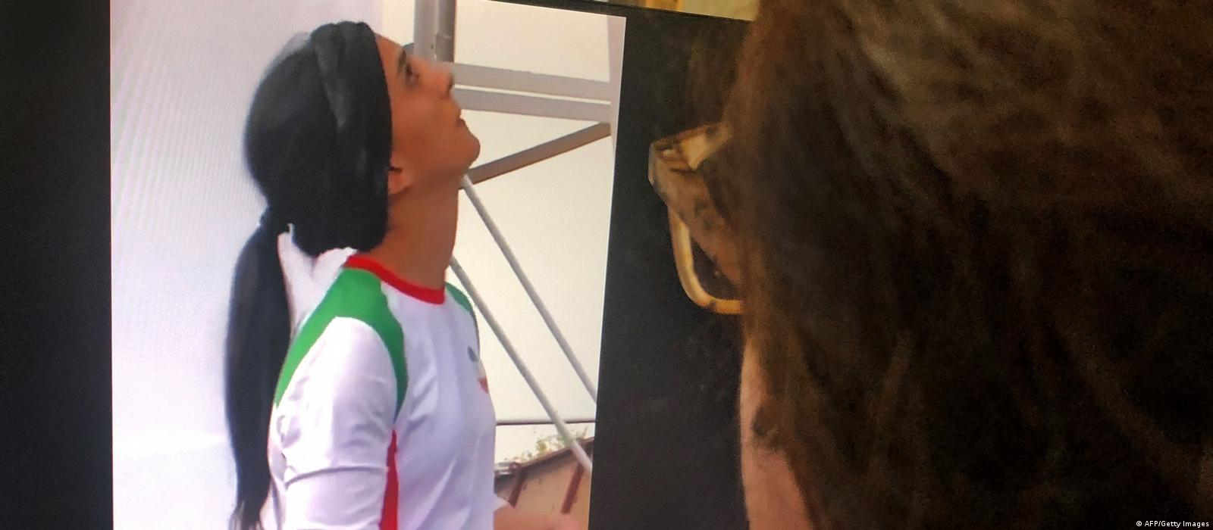
Concerns grew over Rekabi's well-being after she competed in a climbing event without a hijabImage: AFP/Getty Images
Human RightsIran

Iranian climber Elnaz Rekabi arrives back in Tehran
19 october 2022
Worries about Elnaz Rekabi's whereabouts grew after she competed without a hijab at an event in South Korea. She later expressed regret for causing "concerns," but Iranian activists feel her statement was coerced.
https://p.dw.com/p/4INAy
Copy link

Climber appears to get hero's welcome in Iran
02:00
Iranian competitive climber Elnaz Rekabi, who was believed to have gone missing, arrived back in Tehran on Wednesday, according to several media reports.
Large crowds of supporters gathered at the Imam Khomeini International Airport outside of Tehran on Wednesday morning to welcome her back to Iran.
"Elnaz is a hero," they chanted, clapping their hands.
After receiving flowers from a passerby, Rekabi reiterated what she had said on Instagram earlier — that competing without a hijab had been "completely unintentional." She added that her journey back to Iran had been as scheduled.
"We came back to Iran according to the plan. Until this moment everything has been going on according to the plan."
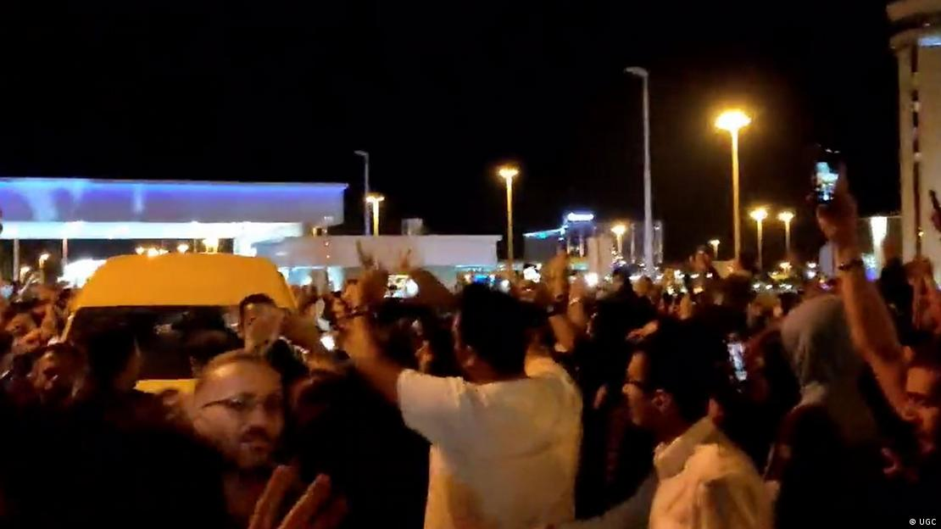
Elnaz Rekabi has been hailed as a 'hero' by supporters on social mediaImage: UGC

Competing without a hijab
The 33-year-old athlete took part in the Asian Sport Climbing Championships in South Korea on Sunday, where she did not wear Iran's mandatory headscarf.
The Islamic republic's strict dress code requires a compulsory headscarf for women, which also apply to all female athletes, including while participating overseas.
As the move was seen as a gesture of solidarity with the women-led protests at home, there has been significant worry for her well-being.
The country has been roiled by protests initially sparked by the death of 22-year-old Jina Mahsa Amini, who died after being arrested by Iranian morality police for allegedly breaching the country's strict rules on head coverings.

Hailed as a 'hero'
According to a stream provided by the International Federation of Sport Climbing, Rekabi wore a bandana over her head during the first discipline of bouldering but switched to only a headband for the next event.
Rekabi has been hailed as a "hero" by supporters on social media, who posted images of her with the protest slogan "Woman. Life. Freedom."
She later expressed regret for causing "concerns" in a post on Instagram, and insisted her appearance without a hijab was "unintentional."
"I firstly apologize for all the concerns I have caused," the statement said. It added that due to the pressing schedule of the events "my hijab unintentionally became problematic."
London-based activist for women's rights Negin Shiraghaei told DW said Rekabi's statement was coerced by Iranian authorities.
"This has been done under duress," Shiraghaei said.

Women's rights activist analyzes Iranian climber case
03:34
Maral Karimi, author of a book on the protests of the Iranian Green Movement of 2009, pointed out that "the authorities have also summoned and arrested her brother, which can only be translated as hostage taking," which Karimi told DW was to force Rekabi to return to Iran.

Protests in Iran continue
Meanwhile, the protests in Iran have entered their fifth week. More than 100 people, including children, have reportedly been killed in the protests that began last month, according to rights groups.
These demonstrations have been one of the strongest challenges to Iran's religious leaders since the 1979 revolution, with protesters demanding the downfall of the Islamic Republic.
ss/rs (AP, EFE, AFP, Reuters)

